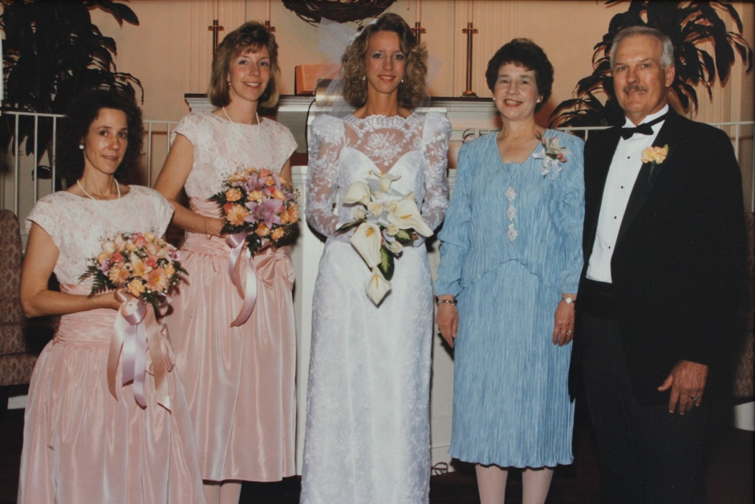

(l-r) Susan, Marilyn, Judie, Jo Ann and Ronald List – 1989

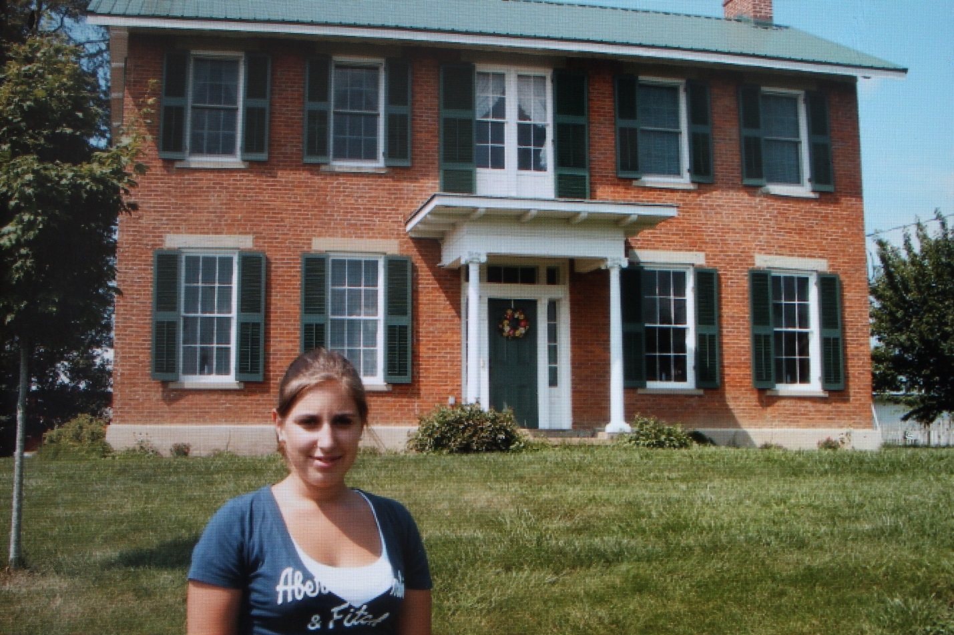

Julia (last name unknown – List cousin from Germany)

in front of Ronald and Jo Ann’s house on Tarlton Pike - 2011